**MODEL EXAM – A SLOT**

8. Draw the UML Diagrams for Hospital Management System and Generate the skeleton Code accorignly.

1. USE CASE DIAGRAM :-

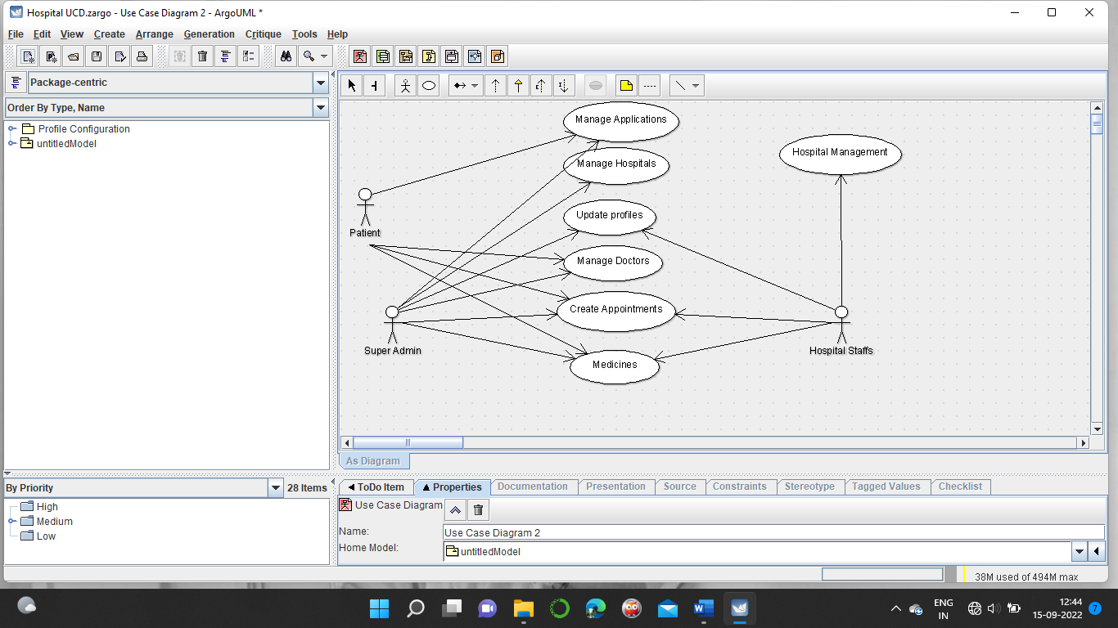

1. **CLASS DIAGRAM :-**

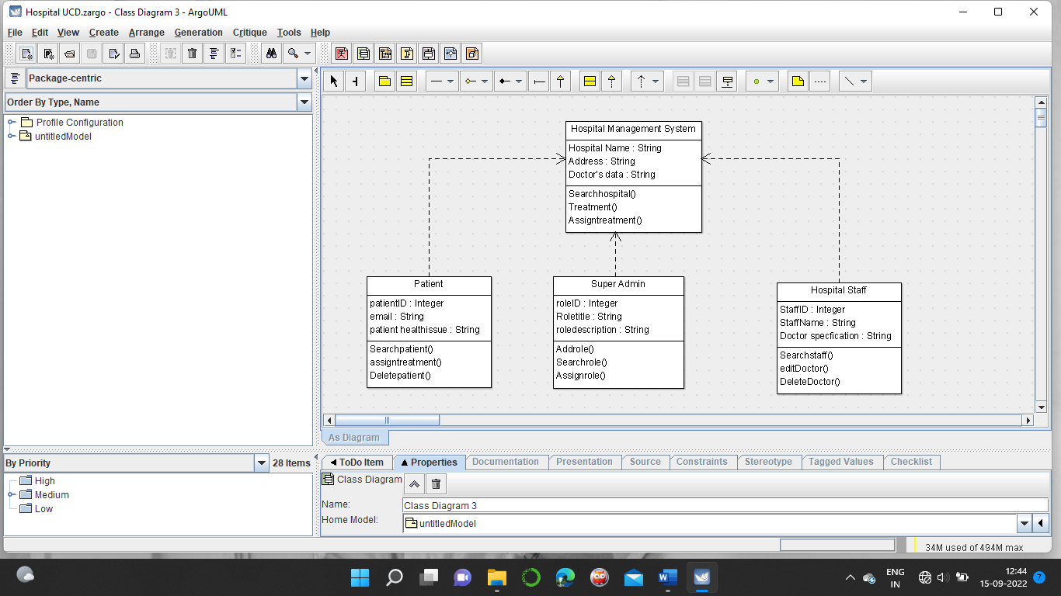

1. **STATE CHART DIAGRAM :-**

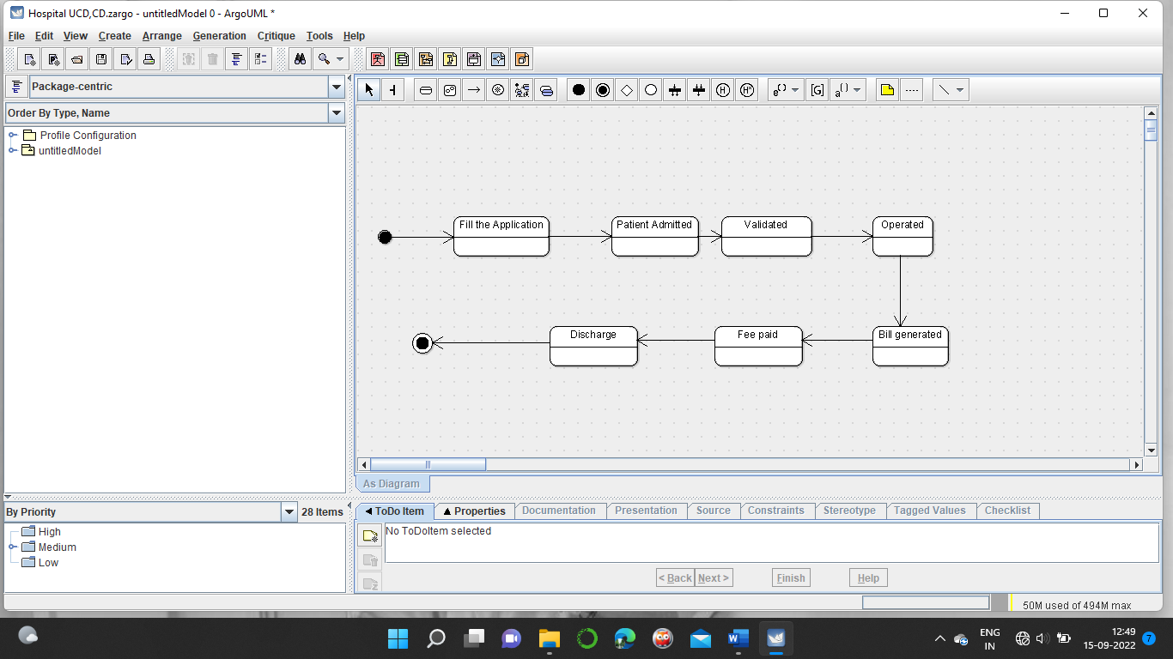

1. SEQUENCE DIAGRAM :-

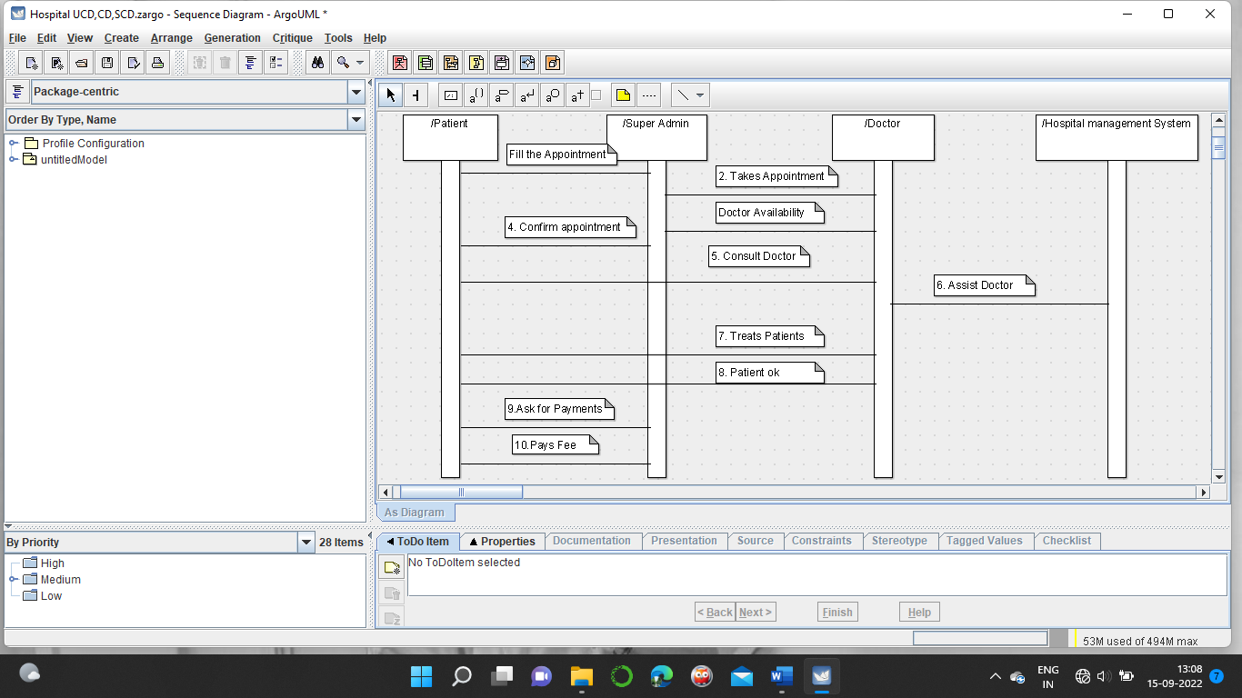

1. **ACTIVITY DIAGRAM :-**

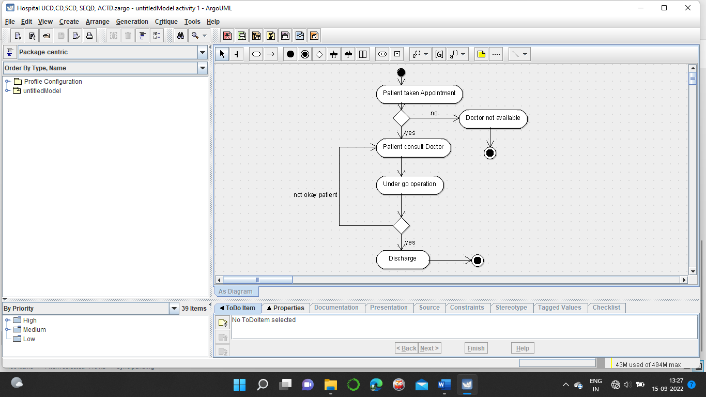

1. **Colloboration Diagram :-**

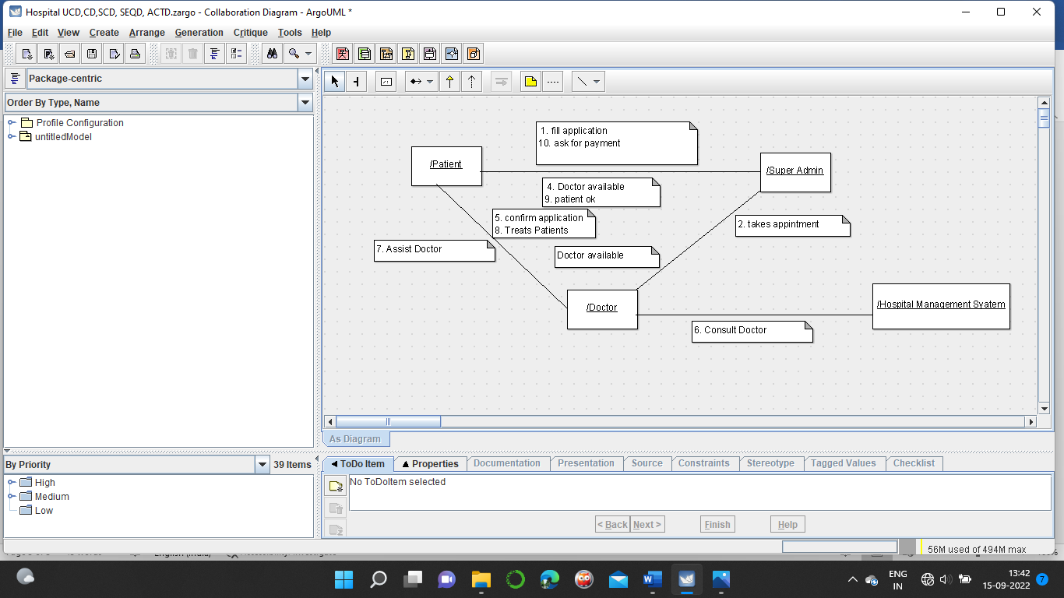

1. **COMPONENT DIAGRAM :-**

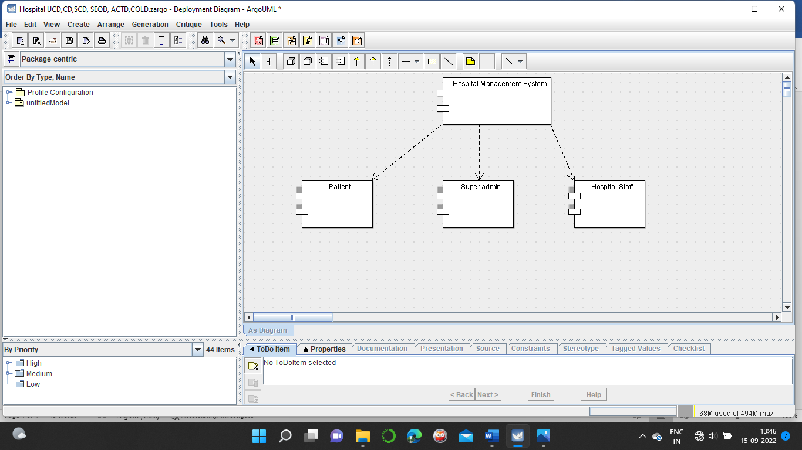

8 . DEPLOYMENT DIAGRAM :-

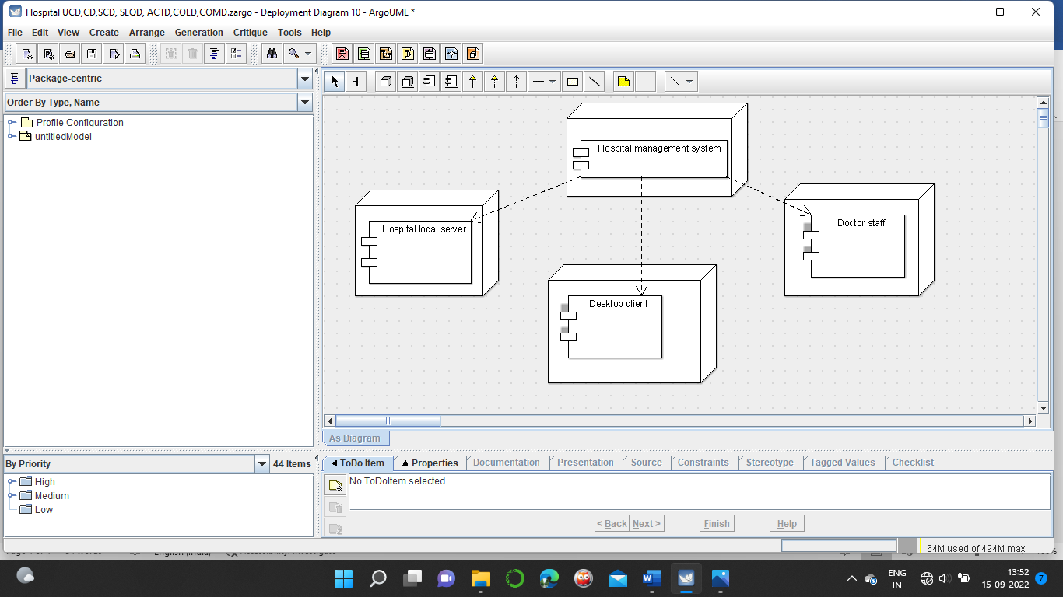

9 package diagram :-

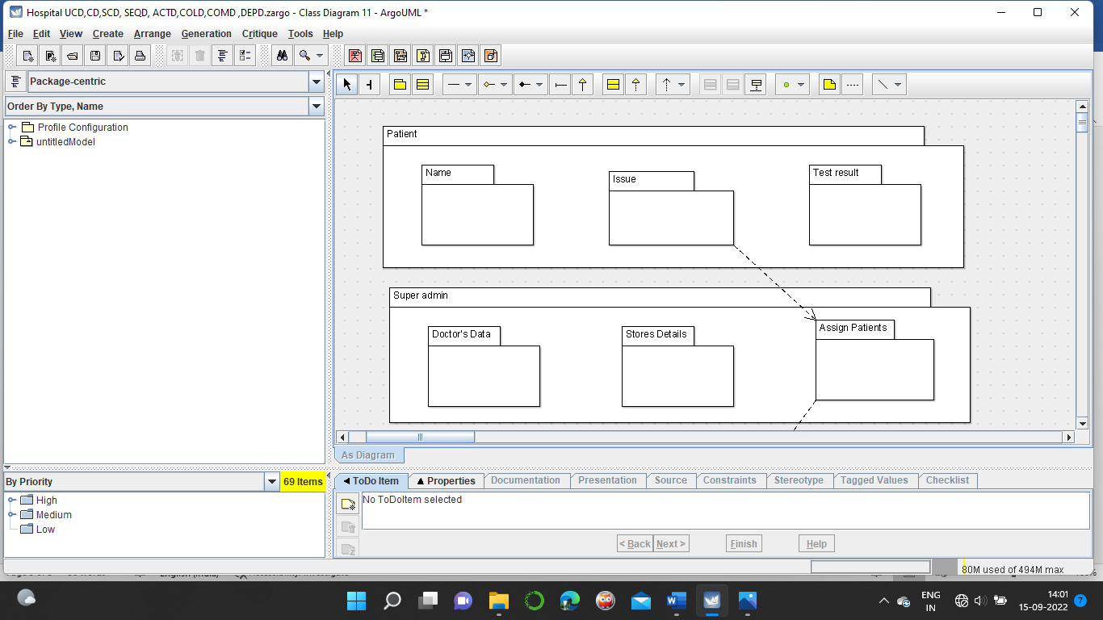

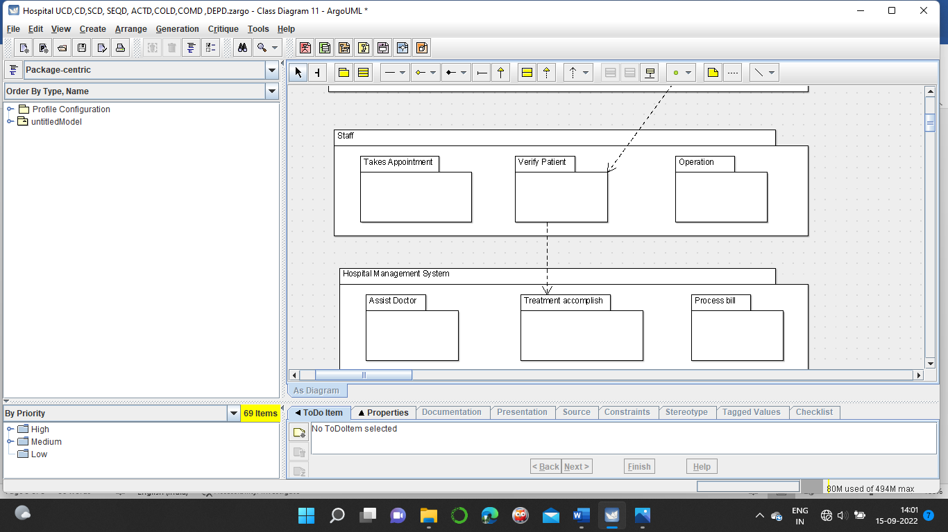

Code :-

**HOSPITAL MANAGEMENT SYSTEM :-**

public class Hospital Management System {

public String Hospital Name;

private String Address;

public String Doctor's data;

private void Searchhospital() {

}

public void Treatment() {

}

public void Assigntreatment() {

}

}

**HOSPITAL STAFF :-**

public class Hospital Staff {

private Integer StaffID;

public String StaffName;

public String Doctor specfication;

public void Searchstaff() {

}

public void editDoctor() {

}

public void DeleteDoctor() {

}

}

**PATIENT :-**

public class Patient {

public Integer patientID;

private String email;

public String patient healthissue;

public void Searchpatient() {

}

public void assigntreatment() {

}

public void Deletepatient() {

}

}

**SUPER ADMIN :-**

public class Patient {

public Integer patientID;

private String email;

public String patient healthissue;

public void Searchpatient() {

}

public void assigntreatment() {

}

public void Deletepatient() {

}

}

RESULT :- Thus the diagrams [use case, activity, sequence, collaboration, class, collaboration, component, deployment, package ] for the Hospital Management system has been designed, executed and output is verified.